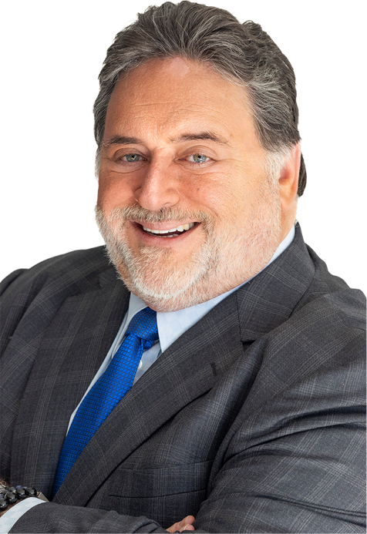
JOE CURCILLO
Cross-Examiner. Mentalist. Negotiator.
Known to audiences as The Maestro of Integration™

Step out of your lane to connect the unseen dots,
and close the Integration Gap™

Leadership is uncertain. The answer lies in that uncertainty.

WHO JOE IS
Forty-one years as a trial lawyer. Forty-eight years on stage. A civil engineering degree underneath all of it. From construction sites to courtrooms, restaurants to negotiating tables, boardrooms to sold-out theaters — Joe Curcillo has spent his career in rooms where the evidence is incomplete, the stakes are real, and someone has to decide anyway. His judgment has been sought by executive leaders across industries.
He is the author of three books, The Generalist's Advantage™, Hold the Horizon™, and Symphony of Disciplines™, and the creator of a leadership tools audit built over three decades of experience courtroom, construction, and boardroom experience.
THE COURTROOM
Mid-career, Joe took on an arson case with a client accused of a crime the evidence didn't support. On cross-examination, Joe dismantled the prosecution's expert witness. Then, drawing on hypnosis-based recall principles, he walked his client through the events to help him remember and testify clearly and credibly. The jury came back with an acquittal.
Afterward, one of the jurors asked to speak to his client's father, waiting anxiously on a call from Bombay, just to tell him: “Your son is a very good man.” Joe has carried that lesson into every boardroom since: facts don't decide anything by themselves. Judgment is what turns evidence into trust, and trust is what lets people act.
That same instinct for reading a room and understanding a person before trying to move them shows up again and again across Joe's career. Early on, he was assigned a client named Lenny, the fourth attorney on the case after the first two were fired and the third was punched. Rather than open with legal strategy, Joe opened by listening; letting Lenny vent, be heard, and be understood before anything else was discussed. “Now I got a lawyer who gets me,” Lenny told him. The legal facts hadn't changed. The relationship had. Joe has seen the same pattern hold true in courtrooms, boardrooms, and conversations ever since: understanding comes before influence, and trust comes before advice.

THE ENGINEERING EYE
Joe's path to law ran through engineering school, and the habits of mind from that training never left him. As a young engineering student in 1981, he watched the aftermath of the Hyatt Regency walkway collapse in Kansas City, a structure that had looked massive, permanent, and safe until, in seconds, it wasn't. Investigators eventually traced the failure not to any act of nature but to a chain of ordinary decisions: a design change, a communication breakdown, an assumption nobody questioned. That early lesson, that catastrophic failure is usually the sum of small, disconnected decisions rather than one dramatic cause, has shaped the way Joe reads organizations ever since. He looks for where the load isn't being carried where everyone assumes it is.
WHY JOE
When a leadership team needs judgment that's actually been tested under pressure, not studied from the outside, that's the person in the room. Joe helps executive leaders exercise judgment across uncertainty and across silos, using 40-plus field-tested tools built for the moment a decision can't wait for certainty.
Every keynote is custom-built for the room, same core thinking, shaped around the industry, the challenges, and the language of the audience in front of him. Every keynote leaves the audience with real tools they can use Monday, not just ideas.
KEYNOTES
Hold the Horizon™ — Maintain direction and judgment when certainty disappears. Built on 40+ field-tested tools and a leadership tools audit.
The Generalist's Advantage™ — Turn cross-disciplinary thinking into a competitive edge.
Symphony of Disciplines™ — Turn separate expertise into one coordinated performance.
FAST FACTS
Author of Hold the Horizon™ • Creator of The Generalist's Advantage™ • Author of Symphony of Disciplines™ • The Maestro of Integration™ • Strategic Advisor • Trial Attorney • Civil Engineer
WHAT PLANNERS SAY
“Joe was easy to work with and took the time to understand our people, our industry, and the real work our members do every day. His keynote connected because it was not a canned speech. It felt built for our room.”
— Tiina Freeman, CAE, AAiP, Director of Strategic Communications & Operations, Northwest Wall & Ceiling Bureau
“...Decisions moved faster. Ownership got clearer. Time stopped getting burned on the same conversations.”
— Jason Reimer, EVP, Chief Infrastructure and Experience Officer, State Employee Credit Union of Maryland
Click Here to Schedule a 30-Minute Planning Conversation
717.645.4930 | joe@joecurcillo.com | linkedin.com/in/joecurcillo

